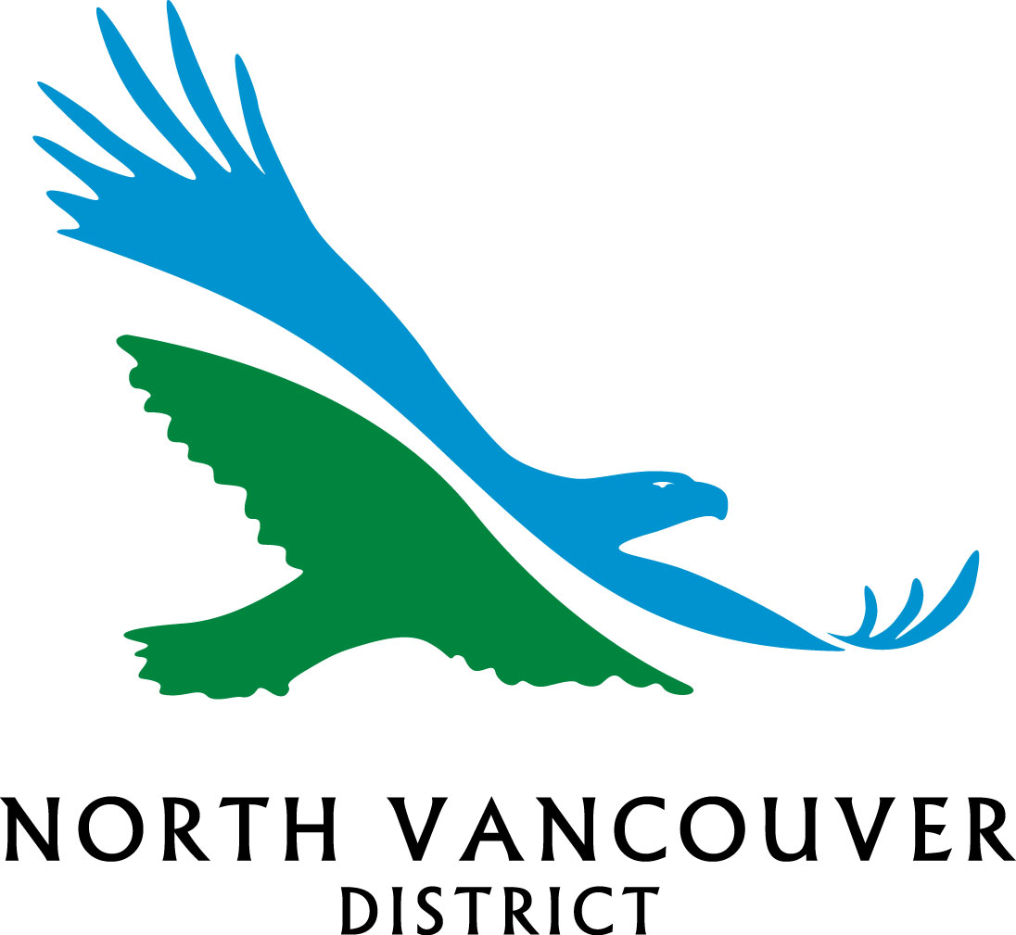
Village Use Permit Application
District of North Vancouver
Economic Development
355 West Queens Rd, North Vancouver, BC V7N 4N5
Questions about this form: Phone: DNV 604 990-2241 or Arts Office 604 980-3559
Or email: film@dnv.org or info@artsoffice.ca
Fax: 604 984-9637

COMPLETION: To ensure legibility, please complete (type) online then print. Sign the printed copy and submit to the department and address indicated above OR

Arts Office, 315 – 1277 Lynn Valley Road, Lynn Valley Village 3rd Floor Library Building;
email: info@artsoffice.ca

Contact Information
Name
Address |  |  |  |  |  |  | Postal Code
Phone |  |  | Cell |  | Fax |  | eMail

Application For
Busking Use
Charitable Use
Non-Profit Event Use
Other

Summary Description
Outline details of your intended activity in the box below. Note intended use of any equipment such as tables, tents, etc.

Attach separate sheet if additional space is required

Location Details
Please indicate the location of your intended activity on the plan below using the identifying letter.
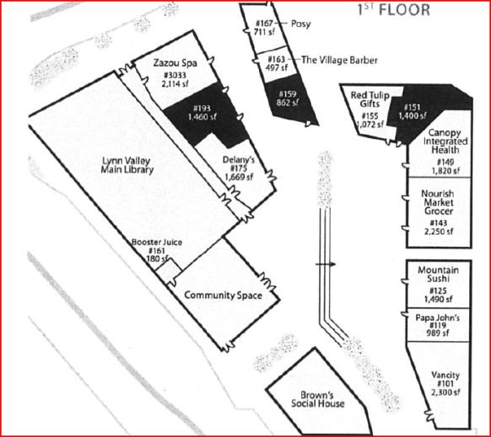
B
E
C

D
A

Describe any location details below, indicating use of services, how you intend to access the site, etc.

Electrical Outlet(s)
Vehicle Access
Other – Please describe in space provided below:
Attach separate sheet if additional space is required

Dates of Events/Activities (Event Use Only)

Date(s)
 | Starting Date |  | Ending Date
Hours
 | Starting Time |  | Ending Time

Dates/Duration of Permit for Busking (Busking Use Only)
Busking Use Permits are 10 weeks in duration.
In order to reserve/schedule specific times, contact at Arts Office at Phone: 604 980-3559 or
email: info@artsoffice.ca

Starting Date |  | Ending Date

Other Considerations Affecting the Use of Space

Name of Applicant |  | Signature
Date

The personal information collected on this form is done so pursuant to the Community Charter and/or the Local Government Act and in accordance with the Freedom of Information and Protection of Privacy Act. The personal information collected herein will be used only for the purpose of processing this application or request and for no other purpose unless its release is authorized by its owner, the information is part of a record series commonly available to the public, or is compelled by a Court or an agent duly authorized under another Act. Further information may be obtained by speaking with The District of North Vancouver’s Manager of Administrative Services at 604-990-2207 or at 355 W Queens Road, North Vancouver.

